Importing libraries In [1]:
import

pandas

as

pd

import

matplotlib.pyplot

as

plt

import

seaborn

as

sns

import

numpy

as

np

# for the Q-Q plots

#import scipy.stats as stats

%
matplotlib
inline

import

pandas

as

pd

pd
.
options
.
display
.
float_format

=

'
{:.2f}
'
.
format

#from pandas.io.json import json_normalize

Loading dataset for receipts In [2]:
receipts

=

pd
.
read_excel
(
"receipts.xlsx"
)

In [3]:
receipts
.
info
()

<class 'pandas.core.frame.DataFrame'> RangeIndex: 1119 entries, 0 to 1118
Data columns (total 15 columns): _id/$oid 1119 non-null object bonusPointsEarned 544 non-null float64 bonusPointsEarnedReason 544 non-null object createDate 1119 non-null int64 dateScanned 1119 non-null int64 finishedDate 568 non-null float64 modifyDate 1119 non-null int64 pointsAwardedDate 537 non-null float64 pointsEarned 609 non-null float64 purchaseDate 671 non-null float64 purchasedItemCount 635 non-null float64 rewardsReceiptItemList 679 non-null object rewardsReceiptStatus 1119 non-null object totalSpent 684 non-null float64 userId 1119 non-null object dtypes: float64(7), int64(3), object(5) memory usage: 131.3+ KB
In [4]:
receipts
.
head
()

Out[4]:
_id/$oid bonusPointsEarned bonusPointsEarnedReason createDate d

0 | 5ff1e1eb0a720f0523000575 | 500.00 | Receipt number 2 completed, bonus point schedu... | 1609687531000 | 160
1 | 5ff1e1bb0a720f052300056b | 150.00 | Receipt number 5 completed, bonus point schedu... | 1609687483000 | 160
2 | 5ff1e1f10a720f052300057a | 5.00 | All-receipts receipt bonus | 1609687537000 | 160
3 | 5ff1e1ee0a7214ada100056f | 5.00 | All-receipts receipt bonus | 1609687534000 | 160
4 | 5ff1e1d20a7214ada1000561 | 5.00 | All-receipts receipt bonus | 1609687506000 | 160

Identifying numerical and categorical variables
In [5]:
# make lists of variable types temporal = [var for var in receipts.columns if 'date' in var or 'Date' in var]
discrete = [
var for var in receipts.columns if receipts[var].dtype != 'O' and len(receipts[var].unique()) < 20 and var not in temporal
]
continuous = [
var for var in receipts.columns if receipts[var].dtype != 'O' if var not in discrete and var != '_id' and var not in temporal
]
categorical = [var for var in receipts.columns if receipts[var].dtype == 'O'
and var not in temporal and var not in discrete]
print(f'There are {len(continuous)} continuous variables') print(f'There are {len(discrete)} discrete variables') print(f'There are {len(temporal)} temporal variables') print(f'There are {len(categorical)} categorical variables')
There are 3 continuous variables
There are 1 discrete variables
There are 6 temporal variables There are 5 categorical variables In [6]:
continuous

Out[6]: ['pointsEarned', 'purchasedItemCount', 'totalSpent'] In [7]:
discrete

Out[7]:
['bonusPointsEarned']
In [8]:
temporal

Out[8]:
['createDate',
'dateScanned',
'finishedDate',
'modifyDate',
'pointsAwardedDate',
'purchaseDate'] In [9]:
categorical

Out[9]:
['_id/$oid',
'bonusPointsEarnedReason',
'rewardsReceiptItemList',
'rewardsReceiptStatus',
'userId']
Quantifying missing data In [10]:
receipts
.
isnull
()
.
sum
()

Out[10]:
_id/$oid 0 bonusPointsEarned 575 bonusPointsEarnedReason 575 createDate 0 dateScanned 0 finishedDate 551 modifyDate 0 pointsAwardedDate 582 pointsEarned 510 purchaseDate 448 purchasedItemCount 484 rewardsReceiptItemList 440 rewardsReceiptStatus 0 totalSpent 435 userId 0 dtype: int64
percentage of missing values in variables In [11]:
# alternatively, we can use the mean() method after isnull() to visualise the percentage o f missing values for each variable
percentage_null_values= receipts.isnull().mean() for key,value in percentage_null_values.items(): if value >0: print(key,":",value*100)
bonusPointsEarned : 51.385165326184094 bonusPointsEarnedReason : 51.385165326184094 finishedDate : 49.240393208221626 pointsAwardedDate : 52.01072386058981 pointsEarned : 45.57640750670242 purchaseDate : 40.03574620196604 purchasedItemCount : 43.25290437890974 rewardsReceiptItemList : 39.32082216264522 totalSpent : 38.8739946380697
A considerate fraction of values are missing from the above mentioned variables. Missing values for certain variables are a major concern:
finishedDate- for 49%(almost half) of the receipts we don't know when do they become invalid(assuming that the date on which a receipt finishes processing is the date on which it becomes invalid) In [12]:
receipts
[
"pointsEarned"
]
.
unique
()

Out[12]:
array([5.00000e+02, 1.50000e+02, 5.00000e+00, 7.50000e+02, 2.50000e+02,
1.00000e+02, 8.85000e+03, 3.00000e+02, nan, 3.89200e+02, 1.85000e+02, 3.50000e+01, 6.50000e+02, 5.50000e+01, 5.00000e+01, 3.55000e+02, 6.00000e+02, 1.75000e+03, 3.50000e+02, 2.25000e+02, 2.75000e+02, 2.50000e+01, 7.55000e+02, 1.80000e+03, 8.10000e+02, 3.05000e+02, 9.44980e+03, 9.12000e+01, 8.25000e+02, 3.50600e+02, 1.25000e+02, 7.93100e+02, 2.00000e+02, 3.25000e+03, 0.00000e+00, 4.00500e+03, 2.00500e+03, 8.41200e+02, 5.75000e+03, 3.75000e+03, 8.70000e+03, 7.60000e+02, 7.80000e+02, 9.20000e+03, 1.00500e+03, 1.99960e+03, 1.89200e+02, 8.95000e+03, 8.85000e+02, 8.00000e+02, 2.95000e+02, 6.82400e+02, 8.37400e+02, 2.37800e+02, 1.60000e+02, 8.55700e+02, 6.05700e+02, 2.41670e+03, 1.80640e+03, 4.05700e+02, 1.51690e+03, 1.65830e+03, 2.68580e+03, 8.79100e+02, 3.65940e+03, 9.34400e+02, 8.77700e+02, 9.22100e+02, 1.54180e+03, 1.00000e+03, 5.74400e+02, 5.06000e+01, 2.05550e+03, 5.85000e+03, 4.85000e+03, 1.73600e+02, 9.85000e+03, 5.09000e+01, 2.30000e+03, 6.73000e+02, 4.05900e+02, 2.14330e+03, 1.55000e+03, 9.86500e+02, 5.83400e+02, 4.48050e+03, 3.37990e+03, 3.23600e+02, 6.25730e+03, 2.49770e+03, 1.17870e+03, 1.44700e+03, 1.72950e+03, 1.47620e+03, 1.70800e+03, 1.07750e+03, 1.13510e+03, 1.04430e+03, 6.40700e+02, 5.23600e+02, 4.87700e+02, 7.13720e+03, 1.20500e+03, 4.00000e+02, 1.01998e+04, 8.50000e+02, 9.46000e+01, 1.85000e+03, 8.40000e+02, 1.04980e+03,
9.40000e+02, 4.94470e+03, 3.75000e+02, 1.49950e+03, 2.09900e+02,
2.09800e+02, 2.10000e+02, 2.09500e+02, 7.89200e+02, 3.50000e+03])
pointsEarned- 45% of the values for the 'pointsEarned' field are missing. If we look at the unique values for 'pointsEarned', we do not have a zero value. This means that points were earned for certain receipts but the data was not captured and that's why the large number of missing values.
purchasedItemCount- large number of missing values will pose problems for deciding if users who bought more than one unit of a product qualify for special offers/bonus points that require them to purchase certain amount of particular products/brands.
totalSpent, rewardsReceiptItemList- Since data for these two fields is missing, it is natural that we don't have information about points earned(pointsEarned field) for those transactions.
Checking for redundant records In [13]:
receipts
[
"_id/$oid"
]
.
unique
()

Out[13]:
array(['5ff1e1eb0a720f0523000575', '5ff1e1bb0a720f052300056b',
'5ff1e1f10a720f052300057a', ..., '603cf5290a720fde10000413', '603ce7100a7217c72c000405', '603c4fea0a7217c72c000389'], dtype=object)
In [14]:
receipts
[
"_id/$oid"
]
.
duplicated
()

Out[14]:
- False
- False
- False
- False
- False ...
- False
- False
- False
- False
- False
Name: _id/$oid, Length: 1119, dtype: bool
In [15]:
duplicateRowsDF = receipts[receipts.duplicated()]
print("Duplicate Rows except first occurrence based on all columns are :") print(duplicateRowsDF)
Duplicate Rows except first occurrence based on all columns are :
Empty DataFrame
Columns: [_id/$oid, bonusPointsEarned, bonusPointsEarnedReason, createDate, d ateScanned, finishedDate, modifyDate, pointsAwardedDate, pointsEarned, purcha seDate, purchasedItemCount, rewardsReceiptItemList, rewardsReceiptStatus, tot alSpent, userId] Index: []
No duplicate records found.
Examining percentage of different category values for categorical variables
Here, the categorical variable of my interest is bonusPointsEarnedReason
In [16]:
freq_reasons = 100*(receipts['bonusPointsEarnedReason'].value_counts() / len(receipts)) print(freq_reasons.map('{:,.2f} %'.format))
All-receipts receipt bonus 16.35 %
Receipt number 1 completed, bonus point schedule DEFAULT (5cefdcacf3693e0b50e 83a36) 10.63 %
COMPLETE_NONPARTNER_RECEIPT 6.34 %
COMPLETE_PARTNER_RECEIPT 3.49 %
Receipt number 3 completed, bonus point schedule DEFAULT (5cefdcacf3693e0b50e 83a36) 2.77 %
Receipt number 2 completed, bonus point schedule DEFAULT (5cefdcacf3693e0b50e 83a36) 2.68 %
Receipt number 5 completed, bonus point schedule DEFAULT (5cefdcacf3693e0b50e 83a36) 2.41 %
Receipt number 4 completed, bonus point schedule DEFAULT (5cefdcacf3693e0b50e 83a36) 2.32 %
Receipt number 6 completed, bonus point schedule DEFAULT (5cefdcacf3693e0b50e 83a36) 1.61 %
Name: bonusPointsEarnedReason, dtype: object In [ ]:

Plotting outliers using boxplot
In [17]:
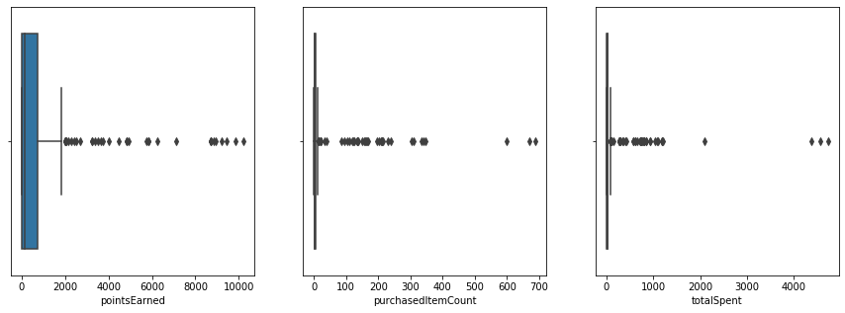
fig
,

axs

=

plt
.
subplots
(
ncols
=
3
,

nrows
=
1
,
figsize
=
(
15
,
5
))

axs

=

axs
.
flatten
()

for

i
,

var

in

enumerate
(
continuous
):

sns
.
boxplot
(
receipts
[
receipts
[
var
]
.
notnull
()][
var
]
,

ax
=
axs
[
i
]
,

orient
=
'h'
)
;

By looking at the boxplots we can say that there is a significantly large range of outliers.
Examining distributions of continuous variables In [18]:
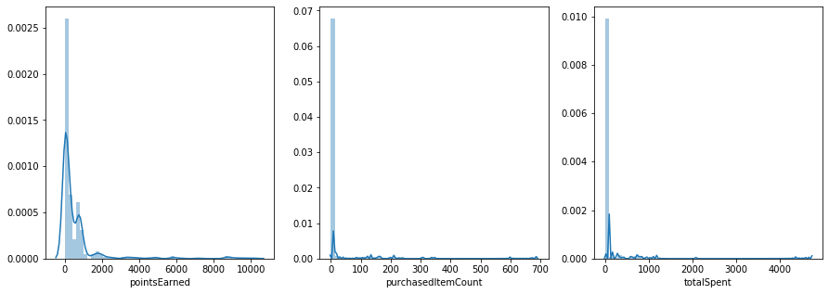
fig
,

axs

=

plt
.
subplots
(
ncols
=
3
,

nrows
=
1
,
figsize
=
(
15
,
5
))

axs

=

axs
.
flatten
()

for

i
,

var

in

enumerate
(
continuous
):

sns
.
distplot
(
receipts
[
receipts
[
var
]
.
notnull
()][
var
]
,

ax
=
axs
[
i
])
;

The distributions for all the three continuous variables are right-skewed.
Both, the boxplots and value distribution diagrams suggest that there are a lot of outliers, but we can't say anything about the significance of these outliers at this point.
Examining corelation between variables In [19]:
import

seaborn

as

sns

f
,

ax

=

plt
.
subplots
(
figsize
=
(
10
,

10
))

corr

=

receipts
.
corr
()

sns
.
heatmap
(
corr
,

mask
=
np
.
zeros_like
(
corr
,

dtype
=
np
.
bool
)
,

square
=
True
,

ax
=
ax

)

Out[19]: <matplotlib.axes._subplots.AxesSubplot at 0x1d25387a7c8>
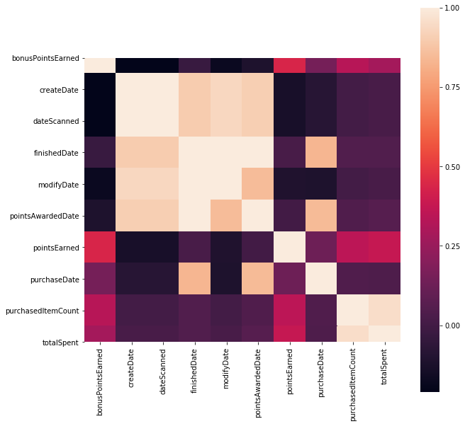
No significant corelations found.
In [ ]:

